# **CS295N Term Project**

Gino Betetta

Description

The site is a community game of cards against humanity which is akin to apples to apples. There are users and each user gets a hand (5 cards), and a prompt to “answer to”. The prompt is sometimes a question but it does not have to be. The user has to try to answer or give the best fitting or funniest card in order to hopefully beat another user who had the same prompt and answers a different card. The way the scores are settled is by voting. The 1st , 2nd , and 3rd place get points based on the number of votes other users give to the cards. There are weekly tournaments and the users get to accumulate points which will be shown in an all time high scores page. The site will also have the current duels that users need to vote on to crown a winner. The ability to create a duel closes on Friday.

Site Map

HomeController:

-Index: brief and long explanation of the site, current highest user score and username

-Highscores: top 5 users

-List of Cards: database search

DuelController:

-Create a user or login

-Start a Duel: Gives you 5 random cards and a prompt that will be matched with another player

If no other player gets matched by Friday then you get dropped.

-Current Weekly Tournament: page to vote and look at the ongoing duels. cant vote for yourself.

-Add a Card: adds a card or prompt to the database (small amount of input validation)

filter out words, make sure it is not already in the database

prompts have to have one set of underlines

character maximum and minimum (3 – 50 characters)

UI sketches

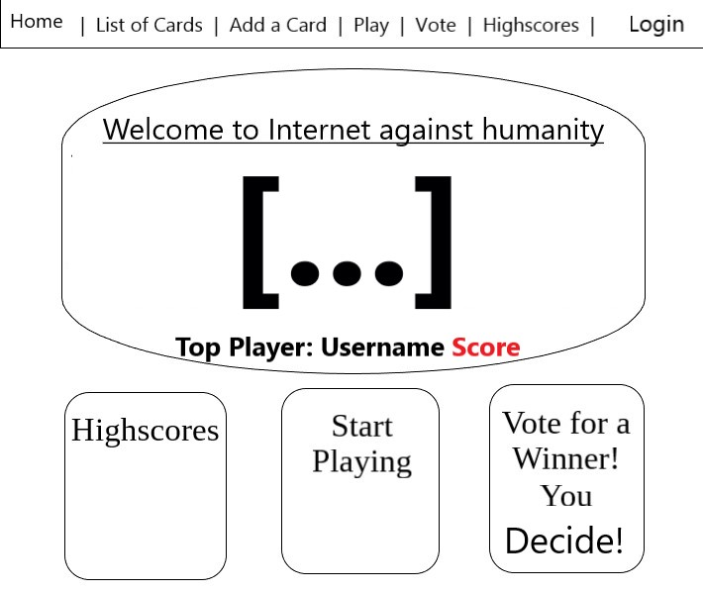

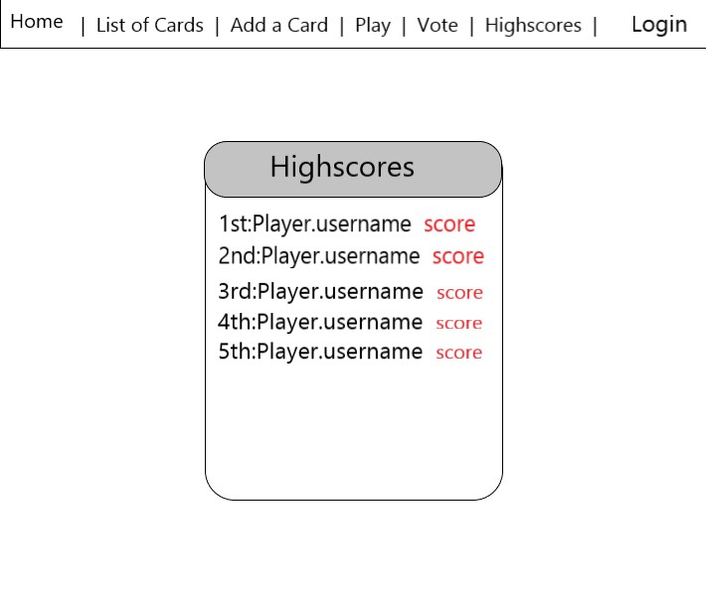

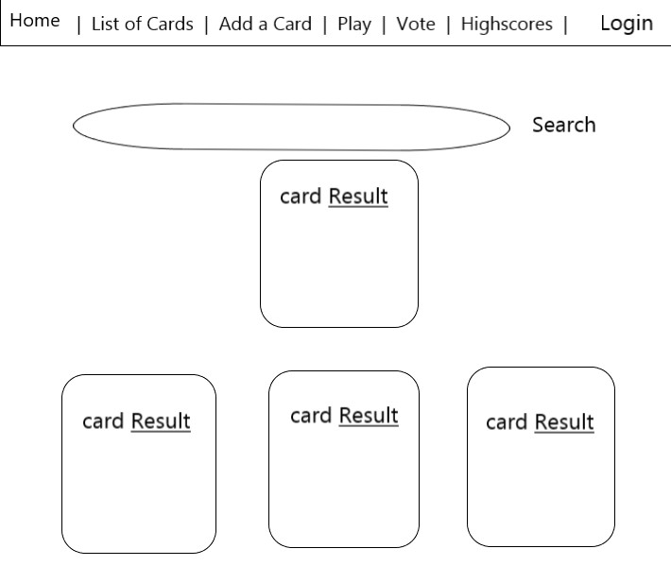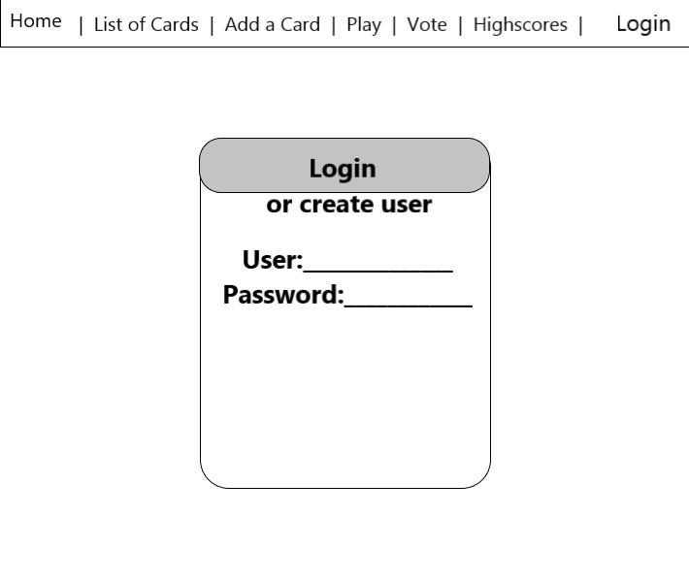

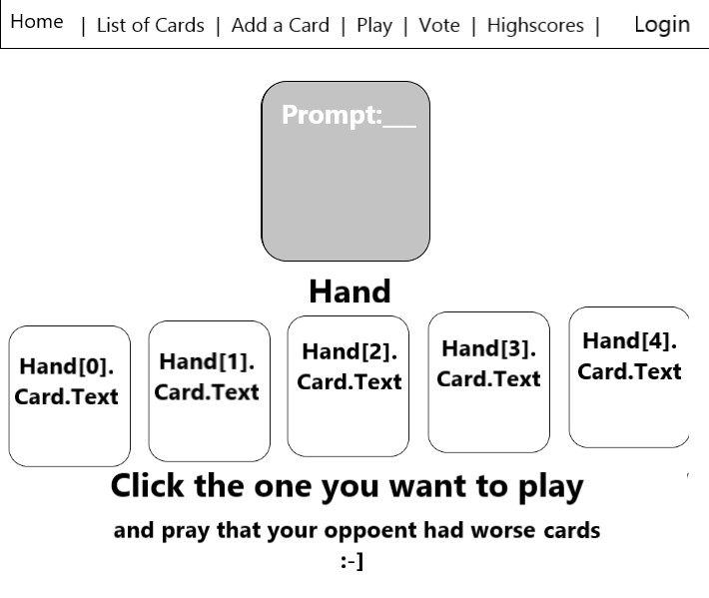

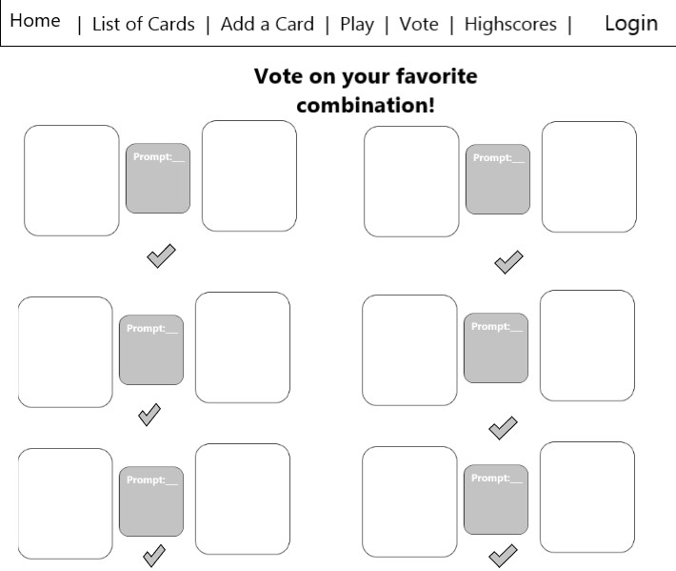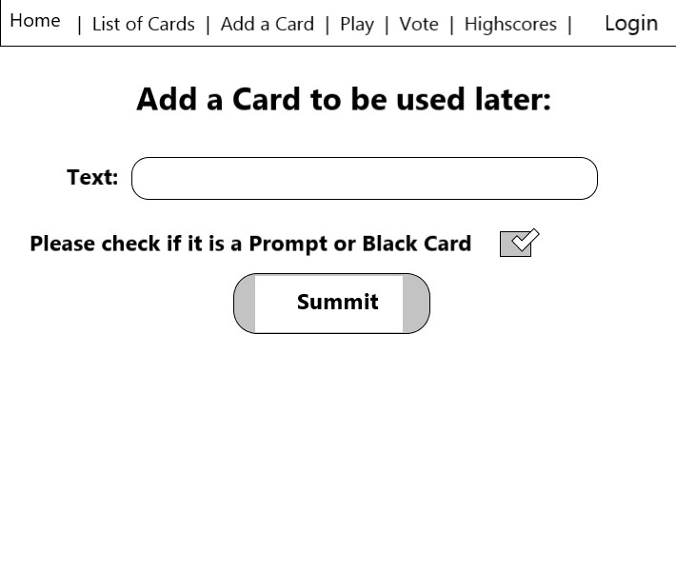

Class Properties

Repository

-ListCards

-ListPrompts

-ListPlayers

Card

-CardID

-IsPrompt - bool

-Text

-PlayedCount

Player

-PlayerID

-Hand

-Username

-Password

-CardChosen

-Score

-Voted – bool

-IsDueling – bool

Duel

-DuelID

-Player1

-Player2

-Player1Votes

-Player2Votes

-Prompt

Tournament

-Duels

-TopAllTimePlayer

-TopWeeklyPlayer

-VoteCount

-GetPlayers